WORKSHEET 30 | PAST SIMPLE (REGULAR VERBS)
Name |  | No. | Class
Date | Mark | Teacher
- Complete the table with the past simple of the verbs.

like |  | watch |  | cry
dance |  | stop |  | cook
invite |  | travel |  | cycle
- Put the verbs in brackets into the past simple.

- I phoned (phone) you in the evening.
- Jane _____________ (wash) her hair after school.
- Will _____________ (study) maths yesterday morning.
- I _____________ (play) with my dog yesterday afternoon.
- John _____________ (paint) his bedroom walls.
- My students _____________ (work) a lot yesterday.
- She _____________ (receive) a postcard from Canada.
- They _____________ (use) their computers yesterday.
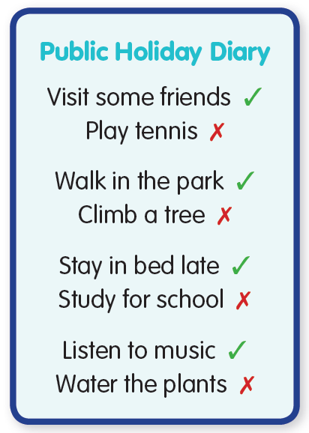
- Look at Linda’s diary. Write affirmative or negative sentences.
- Linda visited some friends, but she didn’t play tennis .
- She __________________________________________________________
_____________________________________________________________.
- ______________________________________________________________
_____________________________________________________________.
- _____________________________________________________________
_____________________________________________________________.
- What did you do last public holiday?
________________________________________________________________________________________________________
________________________________________________________________________________________________________.
ANSWERS

- Complete the table with the past simple of the verbs.

like | liked | watch | watched | cry | cried
dance | danced | stop | stopped | cook | cooked
invite | invited | travel | travelled | cycle | cycled
- Put the verbs in brackets into the past simple.
- I phoned (phone) you in the evening.
- Jane washed (wash) her hair after school.
- Will studied (study) maths yesterday morning.
- I played (play) with my dog yesterday afternoon.
- John painted (paint) his bedroom walls.
- My students worked (work) a lot yesterday.
- She received (receive) a postcard from Canada.
- They used (use) their computers yesterday.
- Look at Linda’s diary. Write affirmative or negative sentences.
- Linda visited some friends, but she didn’t play tennis .
- She walked in the park, but she didn’t climb a tree.
- She stayed in bed late, but she didn’t study for school.
- She listened to music, but she didn’t water the plants.

- What did you do last public holiday?
Personal answers.

